ACTIVITY REQUEST / POS MATERIAL / MARKETING CALENDAR

The Activity Request Module provides a centralized system to manage campaigns, define target audiences, automate communications, and analyze results, with the goal of improving marketing effectiveness and customer engagement.

The POS Material Module is used to code and register all POS materials along with their specific attributes and details, ensuring proper tracking and standardization.

The Marketing Calendar Module enables users to plan marketing activities per supplier and record them in a centralized calendar, facilitating better coordination and visibility of scheduled initiatives.

Since these modules primarily focus on capturing and maintaining structured data, the implementation will emphasize the design of user interface screens required for data entry. These will consist mainly of sub-table maintenance screens and transaction screens used to register and manage the relevant information.

Tables and Sub Tables :
ActivityRequest | Type | Size
Number | Long Integer | 4
Priority | Short Text | 1
Chargeable | Yes/No | 1
RequestedDate | Date | 8
SalesmanCode | Short Text | 3
CustomerCode | Short Text | 6
NonClientCode | Long Integer | 4
SalesGroupCode | Short Text | 1
ActivityTypeCode | Short Text | 6
ActivityTypeSpecialInfo | Short Text | 50
ActivityDate | Date | 8
ActivityPlace | Short Text | 50
ExpectAttendance | Integer | 2
Remarks | Long Text | -
StatusPrevious | Short Text | 1
Status | Short Text | 1
TargetGroupCode | Long Integer | 4
TargetGroup | Short Text | 50
ExpectedPurchase | Single | 4
ExpectedInvestment | Single | 4
Ratio | Byte | 1
ReadyMemo | Long Text | -
ReadyDate | Date | 8
AdviseCode | Short Text | 1
AdviseMemo | Long Text | -
AdviseReason | Short Text | 6
AdviseDate | Date | 8
ApproveCode | Short Text | 1
ApproveMemo | Long Text | -
ApproveReason | Short Text | 6
ApproveDate | Date | 8
InProcessDate | Date | 8
InProcessMemo | Long Text | -
ReadyForInvoiceDate | Date | 8
ReadyForInvoiceMemo | Long Text | -
DateToBeInvoiced | Date | 8
InvoicedDate | Date | 8
InvoicedReference | Short Text | 30
InvoicedMemo | Long Text | -
RenegotiateMemo | Long Text | -
DebitNoteNumber | Long Integer | 4
CancelledDate | Date | 8
CancelledReason | Short Text | 6
CancelledMemo | Long Text | -
BudgetActivity | Short Text | 6
ActivityRequestAddinfo | Type | Size
Number | Long Integer | 4
ActivityTimeFrom | Date | 8
ActivityTimeTill | Date | 8
Entertainment | Short Text | 6
SpecialPrice | Long Text | -
ActivityRqBrands | Type | Size
ActivityRqCode | Long Integer | 4
SequenceNumber | Long Integer | 4
ActivityBudgetType | Integer | 2
BrandCode | Short Text | 3
SupplierCode | Short Text | 3
CostPercentage | Single | 4
BrandStatus | Short Text | 1
DiscountAmount | Double | 8
RDiscountDate | Date | 8
RDiscountAmount | Double | 8
RDiscountReference | Short Text | 30
BrInvoicedDate | Date | 8
BrInvoicedReference | Short Text | 30
BrInvoicedMemo | Long Text | -
BrDebitNoteNumber | Long Integer | 4
ActivityRqCash | Type | Size
ActivityRqCode | Long Integer | 4
SequenceNumber | Long Integer | 4
ActivityBudgetType | Integer | 2
Date | Date | 8
CashAmount | Double | 8
AmountType | Short Text | 2
TransactionSpec | Short Text | 75
RCashDate | Date | 8
RCashAmount | Double | 8
RCashReference | Short Text | 75
ActivityRqJobOrders | Type | Size
ActivityRqCode | Long Integer | 4
JobDatePrinted | Date | 8
JobIssuedBy | Short Text | 30
JobBrandCount | Byte | 1
JobBrandForecasted | Double | 8
JobBrandDateSignOff | Date | 8
JobBrandToBookBy | Short Text | 30
JobBrandDateBooked | Date | 8
JobBrandBookedAmnt | Double | 8
JobBrandBookedBy | Short Text | 30
JobProductCount | Byte | 1
JobProductForecasted | Double | 8
JobProductDateSignOff | Date | 8
JobProductToBookBy | Short Text | 30
JobProductDateBooked | Date | 8
JobProductBookedAmnt | Double | 8
JobProductBookedBy | Short Text | 30
JobCashCACount | Byte | 1
JobCashCAForecasted | Double | 8
JobCashCADateSignOff | Date | 8
JobCashCAToBookBy | Short Text | 30
JobCashCADateBooked | Date | 8
JobCashCABookedAmnt | Double | 8
JobCashCABookedBy | Short Text | 30
JobCashCHCount | Byte | 1
JobCashCHForecasted | Double | 8
JobCashCHDateSignOff | Date | 8
JobCashCHToBookBy | Short Text | 30
JobCashCHDateBooked | Date | 8
JobCashCHBookedAmnt | Double | 8
JobCashCHBookedBy | Short Text | 30
JobPrintCount | Byte | 1
JobPrintForecasted | Double | 8
JobPrintDateSignOff | Date | 8
JobPrintToBookBy | Short Text | 30
JobPrintDateBooked | Date | 8
JobPrintBookedAmnt | Double | 8
JobPrintBookedBy | Short Text | 30
JobRadioCount | Byte | 1
JobRadioForecasted | Double | 8
JobRadioDateSignOff | Date | 8
JobRadioToBookBy | Short Text | 30
JobRadioDateBooked | Date | 8
JobRadioBookedAmnt | Double | 8
JobRadioBookedBy | Short Text | 30
JobPOSCount | Byte | 1
JobPOSForecasted | Double | 8
JobPOSDateSignOff | Date | 8
JobPOSToBookBy | Short Text | 30
JobPOSDateBooked | Date | 8
JobPOSBookedAmnt | Double | 8
JobPOSBookedBy | Short Text | 30
JobPromoCount | Byte | 1
JobPromoForecasted | Double | 8
JobPromoDateSignOff | Date | 8
JobPromoToBookBy | Short Text | 30
JobPromoDateBooked | Date | 8
JobPromoBookedAmnt | Double | 8
JobPromoBookedBy | Short Text | 30
JobOthersCount | Byte | 1
JobOthersForecasted | Double | 8
JobOthersDateSignOff | Date | 8
JobOthersToBookBy | Short Text | 30
JobOthersDateBooked | Date | 8
JobOthersBookedAmnt | Double | 8
JobOthersBookedBy | Short Text | 30
ActivityRqJobSpec | Type | Size
ARJobSpecNumber | Integer | 2
ARJobSpecSpec | Short Text | 6
ARJobSpecBudgetAct | Short Text | 6
ActivityRqOthers | Type | Size
ActivityRqCode | Long Integer | 4
SequenceNumber | Long Integer | 4
ActivityBudgetType | Integer | 2
SponsoringType | Short Text | 6
TypeSpecification | Short Text | 10
SizeSpecification | Short Text | 10
Quantity | Integer | 2
Amount | Double | 8
ROthersDate | Date | 8
ROthersAmount | Double | 8
ROthersReference | Short Text | 30
ActivityRqPOSAddInfo | Type | Size
ActivityRqCode | Long Integer | 4
SequenceNumber | Long Integer | 4
POS_Drop_Off_Date | Date | 8
POS_Drop_Off_Time | Date | 8
POS_Pick_Up_Date | Date | 8
POS_Pick_Up_Time | Date | 8
POS_Person_Respons | Short Text | 50
POS_Instructions | Long Text | -
POS_Person_Tel | Short Text | 50
ActivityRqPOSMaterial | Type | Size
ActivityRqCode | Long Integer | 4
SequenceNumber | Long Integer | 4
ActivityBudgetType | Integer | 2
POSMaterialCode | Integer | 2
POSMaterialDescr | Short Text | 75
POSPrice | Single | 4
LendGive | Short Text | 1
LendGive_Descr | Short Text | 15
Truck_Dlvry | Yes/No | 1
QtyOut | Integer | 2
QtyIn | Integer | 2
QtyNotIn | Integer | 2
DateQtyIn | Date | 8
SP_SerialNumber | Yes/No | 1
AR_POS_SerialNumber | Short Text | 100
SP_Exp_Purchase | Yes/No | 1
AR_POS_Exp_Purchase | Double | 8
AR_POS_Exp_Purchase_Txt | Short Text | 50
SP_Objective | Yes/No | 1
AR_POS_Objective | Short Text | 255
SP_Contract | Yes/No | 1
AR_POS_Contract_Start | Date | 8
AR_POS_Duration_Mon | Integer | 2
AR_POS_Contract_End | Date | 8
AR_POS_Contract_Type | Short Text | 25
AR_POS_Contract_Num | Long Integer | 4
AR_POS_Model_Type | Short Text | 25
AR_POS_Maint_Months | Integer | 2
AR_POS_KVK_Num | Short Text | 15
AR_POS_Capacity | Integer | 2
AR_POS_Insurrance | Double | 8
AR_POS_Contract_Sign | Date | 8
AR_POS_EXP_PURCH_PERC | Double | 8
AR_POS_CUST_NAME | Short Text | 50
AR_POS_COMPANY | Short Text | 50
ActivityRqPOSMaterial_Returns | Type | Size
ActivityRqCode | Long Integer | 4
SequenceNumber | Long Integer | 4
StatusSequenceNumber | Long Integer | 4
QtyIn | Integer | 2
POS_Return_Status | Short Text | 25
POS_Return_Stock | Yes/No | 1
ActivityRqPrint | Type | Size
ActivityRqCode | Long Integer | 4
SequenceNumber | Long Integer | 4
ActivityBudgetType | Integer | 2
FacilitatorsCode | Short Text | 6
Date | Date | 8
DateTill | Date | 8
Frequency | Integer | 2
Size | Short Text | 10
AmntForecast | Double | 8
RPrintDate | Date | 8
RPrintAmount | Double | 8
RPrintReference | Short Text | 30
ActivityRqProducts | Type | Size
ActivityRqCode | Long Integer | 4
SequenceNumber | Long Integer | 4
ActivityBudgetType | Integer | 2
ProductCode | Short Text | 6
Quantity | Integer | 2
ProdPrice | Single | 4
ProdDiscount | Single | 4
RprodDate | Date | 8
RProdQty | Integer | 2
RProdPrice | Single | 4
RProdReference | Short Text | 30
RProdBookedAmount | Double | 8
ActivityRqPromotions | Type | Size
ActivityRqCode | Long Integer | 4
SequenceNumber | Long Integer | 4
ActivityBudgetType | Integer | 2
PromotionCode | Short Text | 6
Quantity | Integer | 2
UnitPrice | Single | 4
RPromDate | Date | 8
RPromQty | Integer | 2
RPromPrice | Single | 4
RPromReference | Short Text | 30
ActivityRqRadio | Type | Size
ActivityRqCode | Long Integer | 4
SequenceNUmber | Long Integer | 4
ActivityBudgetType | Integer | 2
FacilitatorsCode | Short Text | 6
Date | Date | 8
DateTill | Date | 8
Frequency | Integer | 2
AmntForecast | Double | 8
RRadioDate | Date | 8
RRadioAmount | Double | 8
RRadioReference | Short Text | 30
ActivityType | Type | Size
Code | Short Text | 6
Description | Short Text | 30
Activity_Related | Yes/No | 1
AP_Vendor_Master | Type | Size
VENDOR_NUMBER | Long Integer | 4
VENDOR_NAME | Short Text | 255
STREET_ADDRESS | Short Text | 255
PO_BOX | Short Text | 255
CITY | Short Text | 255
STATE_CODE | Short Text | 255
PHONE# | Short Text | 255
ZIP4CODE | Short Text | 255
FAX# | Short Text | 255
E_MAIL | Short Text | 255
AR_USERS | Type | Size
USERID | Short Text | 8
USERNAME | Short Text | 35
PASSWORD | Short Text | 8
TYPEOFUSER | Short Text | 1
UPDATE_BUDGETS | Yes/No | 1
VIEW_BRANDBUDGETS | Yes/No | 1
VIEW_CUSTBUDGETS | Yes/No | 1
BudgetActivities | Type | Size
Code | Short Text | 6
Description | Short Text | 50
BillingDescr | Short Text | 30
DisplaySeq | Integer | 2
CAT_Add_Specs | Type | Size
CAT_Sel | Short Text | 50
CAT_Apparel_Type | Type | Size
CAT_Sel | Short Text | 25
CAT_Bag_Specs | Type | Size
CAT_Sel | Short Text | 25
CAT_Bottles | Type | Size
CAT_Sel | Short Text | 25
CAT_Brand_Specific | Type | Size
CAT_Sel | Short Text | 25
CAT_Clothing_Type | Type | Size
CAT_Sel | Short Text | 25
CAT_Colors | Type | Size
CAT_Sel | Short Text | 25
CAT_Content | Type | Size
CAT_Sel | Short Text | 25
CAT_Cooler_Capacity | Type | Size
CAT_Sel | Short Text | 25
CAT_Cooler_Model | Type | Size
CAT_Sel | Short Text | 25
CAT_Cooler_Type | Type | Size
CAT_Sel | Short Text | 25
CAT_Prefix | Short Text | 1
CAT_FileNames | Type | Size
File_Names | Short Text | 25
Display_Text | Short Text | 25
CAT_Gender | Type | Size
CAT_Sel | Short Text | 25
CAT_Glass_Serving | Type | Size
CAT_Sel | Short Text | 25
CAT_Insurrance | Type | Size
CAT_Sel | Short Text | 25
CAT_LED | Type | Size
CAT_Sel | Short Text | 25
CAT_Maint_Months | Type | Size
CAT_Sel | Short Text | 25
CAT_Materilas | Type | Size
CAT_Sel | Short Text | 25
CAT_Shapes | Type | Size
CAT_Sel | Short Text | 25
CAT_Sizes | Type | Size
CAT_Sel | Short Text | 25
CAT_VAP_Type | Type | Size
CAT_Sel | Short Text | 25
CompanyInfo | Type | Size
Code | Byte | 1
Name | Short Text | 50
Address | Short Text | 50
Telephone | Short Text | 15
Fax | Short Text | 15
E-mail | Short Text | 30
SponsTypePrint | Short Text | 6
SponsTypeRadio | Short Text | 6
SponsTypeCashCA | Short Text | 6
SponsTypeCashCH | Short Text | 6
SponsTypeProduct | Short Text | 6
SponsTypePOS | Short Text | 6
SponsTypePromo | Short Text | 6
SponsTypeOther | Short Text | 6
VisitReportDate2 | Date | 8
VisitReportDate1 | Date | 8
VisitReportLastDate | Date | 8
VisitReportNewDate | Date | 8
VisitReportInitDate | Date | 8
BrandToBookBy | Short Text | 30
ProductToBookBy | Short Text | 30
CashCAToBookBy | Short Text | 50
CashCHToBookBy | Short Text | 30
PrintToBookBy | Short Text | 30
RadioToBookBy | Short Text | 30
POSToBookBy | Short Text | 30
PromoToBookBy | Short Text | 30
OthersToBookBy | Short Text | 30
AuthorizationNo | Long Integer | 4
Allowed_Percentage | Double | 8
POS_Pic_Path | Short Text | 255
CustomerNonClient | Type | Size
CNC_Seq | Long Integer | 4
CNC_Name | Short Text | 50
CustomerSalesGroup | Type | Size
SalesGroupType | Short Text | 1
SalesGroupDescription | Short Text | 50
SalesGroupAmountFrom | Double | 8
SalesGroupAmountTill | Double | 8
CustomerSegmentInfo | Type | Size
Code | Short Text | 2
Description | Short Text | 50
CodeProductMix | Short Text | 1
CustomerTargetGroup | Type | Size
TargetCode | Long Integer | 4
TargetGroupDesc | Short Text | 50
DenialReasons | Type | Size
DenialCode | Short Text | 6
DenialDescription | Short Text | 50
EntertainmentType | Type | Size
Code | Short Text | 6
Description | Short Text | 30
FacilitatorsInfo | Type | Size
Code | Short Text | 6
Name | Short Text | 45
StreetAddress | Short Text | 60
City | Short Text | 30
StateOrProvince | Short Text | 20
PostalCode | Short Text | 15
Country | Short Text | 50
ContactPerson | Short Text | 50
ContactPhoneNumber | Short Text | 20
PhoneNumber | Short Text | 20
FaxNumber | Short Text | 20
Email | Short Text | 30
Notes | Long Text | -
FiscalYears | Type | Size
YearNumber | Integer | 2
LicoresGroup | Type | Size
LG_Number | Short Text | 6
LG_Name | Short Text | 50
LocationInfo | Type | Size
Code | Short Text | 6
Description | Short Text | 30
MIS_Activity_Type | Type | Size
MAT_ActCode | Short Text | 6
MAT_ProdClass | Short Text | 2
MAT_ActYear | Integer | 2
MAT_ActQty_01 | Integer | 2
MAT_ActBud_01 | Double | 8
MAT_ActReal_01 | Double | 8
MAT_ActQty_02 | Integer | 2
MAT_ActBud_02 | Double | 8
MAT_ActReal_02 | Double | 8
MAT_ActQty_03 | Integer | 2
MAT_ActBud_03 | Double | 8
MAT_ActReal_03 | Double | 8
MAT_ActQty_04 | Integer | 2
MAT_ActBud_04 | Double | 8
MAT_ActReal_04 | Double | 8
MAT_ActQty_05 | Integer | 2
MAT_ActBud_05 | Double | 8
MAT_ActReal_05 | Double | 8
MAT_ActQty_06 | Integer | 2
MAT_ActBud_06 | Double | 8
MAT_ActReal_06 | Double | 8
MAT_ActQty_07 | Integer | 2
MAT_ActBud_07 | Double | 8
MAT_ActReal_07 | Double | 8
MAT_ActQty_08 | Integer | 2
MAT_ActBud_08 | Double | 8
MAT_ActReal_08 | Double | 8
MAT_ActQty_09 | Integer | 2
MAT_ActBud_09 | Double | 8
MAT_ActReal_09 | Double | 8
MAT_ActQty_10 | Integer | 2
MAT_ActBud_10 | Double | 8
MAT_ActReal_10 | Double | 8
MAT_ActQty_11 | Integer | 2
MAT_ActBud_11 | Double | 8
MAT_ActReal_11 | Double | 8
MAT_ActQty_12 | Integer | 2
MAT_ActBud_12 | Double | 8
POS_Brands | Type | Size
PB_BrandCode | Short Text | 10
PB_BrandDesc | Short Text | 50
PB_VIP_BrandCode | Short Text | 3
POS_Category | Type | Size
PC_Category | Short Text | 25
POS_LendGive | Type | Size
PLG_Code | Short Text | 1
PLG_Descr | Short Text | 10
POS_Materials | Type | Size
POS_Product_Num | Long Integer | 4
POS_Product_Name | Short Text | 25
POS_BrandCode | Short Text | 10
POS_Category | Short Text | 25
POS_Spec_1 | Yes/No | 1
POS_Spec_1_Cat | Short Text | 25
POS_Spec_1_Sel | Short Text | 25
POS_Spec_2 | Yes/No | 1
PoS_Spec_2_Cat | Short Text | 25
PoS_Spec_2_Sel | Short Text | 25
POS_Spec_3 | Yes/No | 1
POS_Spec_3_Cat | Short Text | 25
POS_Spec_3_Sel | Short Text | 25
POS_Spec_4 | Yes/No | 1
POS_Spec_4_Cat | Short Text | 25
POS_Spec_4_Sel | Short Text | 25
POS_Spec_5 | Yes/No | 1
POS_Spec_5_Cat | Short Text | 25
POS_Spec_5_Sel | Short Text | 25
POS_Add_Specs | Yes/No | 1
POS_Add_Specs_Sel | Short Text | 25
POS_Cost | Double | 8
POS_Price | Double | 8
POS_Location | Short Text | 10
POS_Qty_OH | Integer | 2
POS_Pic | Short Text | 100
POS_LendGive | Short Text | 1
POS_ItemCode | Short Text | 50
POS_Location_Bulk | Short Text | 10
POS_Qty_Bulk | Integer | 2
POS_Setup_Required | Yes/No | 1
POS_Setup_Cost | Double | 8
POS_Deposit | Double | 8
POS_Qty_Reserved | Integer | 2
POS_Truck_Dlvry | Yes/No | 1
POS_SerialNumber | Yes/No | 1
POS_Exp_Purchase | Yes/No | 1
POS_Objective | Yes/No | 1
POS_Contract | Yes/No | 1
POS_Contract_Type | Short Text | 25
POS_Model_Type | Short Text | 25
POS_Maint_Months | Integer | 2
POS_Capacity | Integer | 2
POS_Insurrance | Double | 8
POS_Materials_Status | Type | Size
PMS_Text | Short Text | 25
PMS_Return_Stock | Yes/No | 1
POS_Product_Specs | Type | Size
PPS_Product_Name | Short Text | 25
PPS_Category | Short Text | 25
PPS_Spec_1 | Yes/No | 1
PPS_Spec_1_Cat | Short Text | 25
PPS_Spec_2 | Yes/No | 1
PPS_Spec_2_Cat | Short Text | 25
PPS_Spec_3 | Yes/No | 1
PPS_Spec_3_Cat | Short Text | 25
PPS_Spec_4 | Yes/No | 1
PPS_Spec_4_Cat | Short Text | 25
PPS_Spec_5 | Yes/No | 1
PPS_Spec_5_Cat | Short Text | 25
PPS_Add_Specs | Yes/No | 1
PPS_LendGive | Short Text | 1
PPS_Truck_Dlvry | Yes/No | 1
PPS_SerialNumber | Yes/No | 1
PPS_Exp_Purchase | Yes/No | 1
PPS_Objective | Yes/No | 1
PPS_Contract | Yes/No | 1
PPS_Contract_Spec_Seq | Integer | 2
PPS_Cooler_Model_Seq | Integer | 2
PPS_Maint_Months_Seq | Integer | 2
PPS_Capacity_Seq | Integer | 2
PPS_Insurrance_Seq | Integer | 2
SponsoringType | Type | Size
Code | Short Text | 6
Description | Short Text | 30
BudgetActivity | Short Text | 6
StatusCodes | Type | Size
ST_Code | Short Text | 1
ST_Description | Short Text | 25
ST_Reason | Yes/No | 1

REGISTER MARKETING CALENDAR ACTIVITIES:

Register Supplier/Brand Planning:
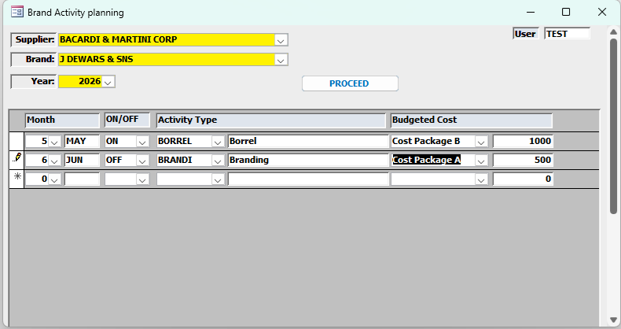
Input Section (Header Filters)
These fields define the context before entering activities:
- Supplier (Dropdown)
- Brand (Dependent Dropdown)
- Year (Dropdown or numeric input)

Activity Entry Section
Once the header is selected, the user can add one or multiple activity rows.
Fields per Activity:
- Month (Dropdown)
- Customer Type (Dropdown) → ON / OFF
- Activity Type (Dropdown)
- Budgeted Cost (Dropdown)

Display Supplier/Brand Planning:
The planning can be displayed per Year, Year/Month or Year/Brand.
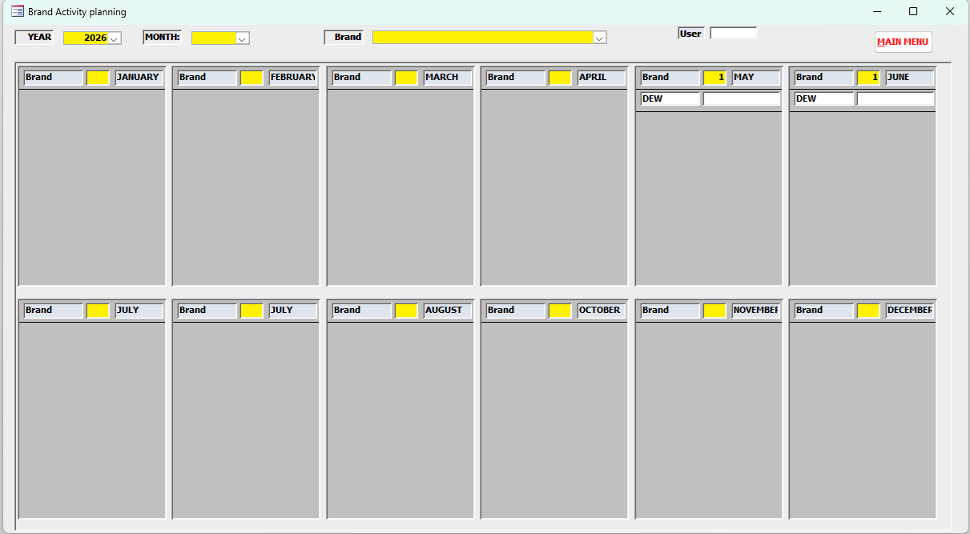
YEAR/MONTH
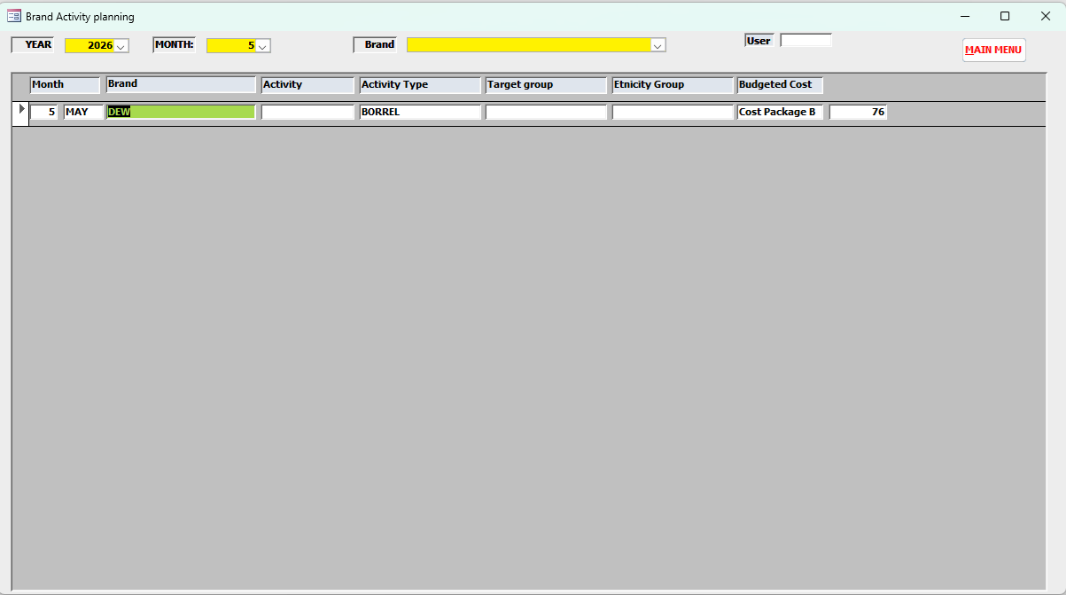

YEAR/BRAND
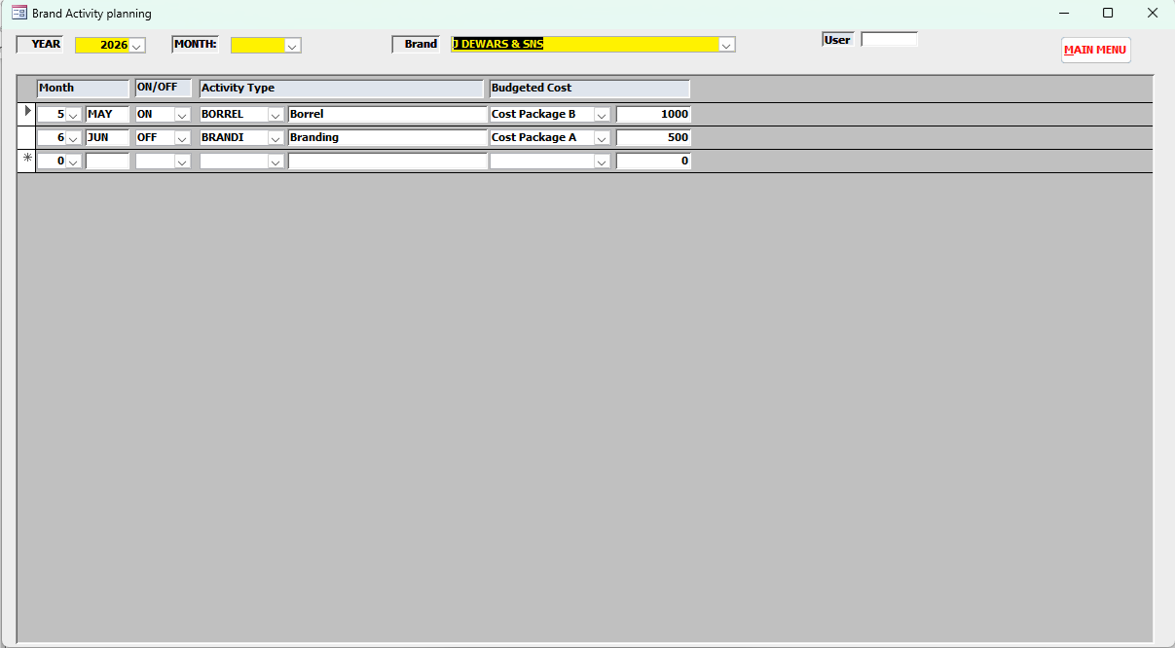

The created marketing planning can be scheduled in the marketing calendar in the Activity Request Module.

REGISTER ACTIVITY REQUEST:

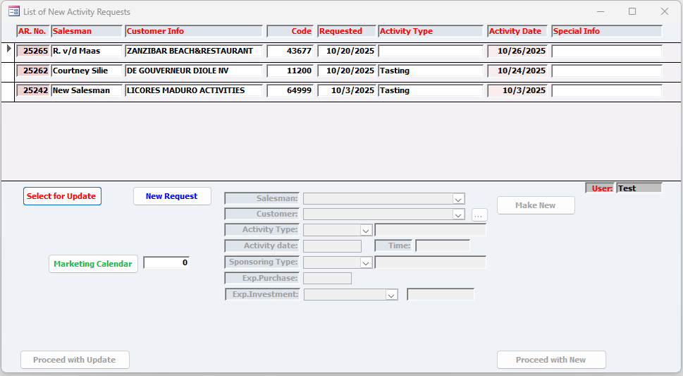

The user has the option to:
- Select an existing, not ready Activity Request, for update,
- Create a new activity request,
- Plan a marketing activity on a marketing calendar.

Select an existing, not ready, activity for update:
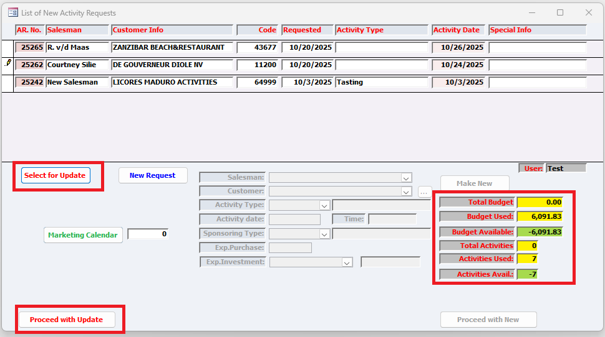

- Select the activity request,
- Press select for update; a calculation will be made of the already created activities,
- Select “Proceed with update”.

Make new Activity:
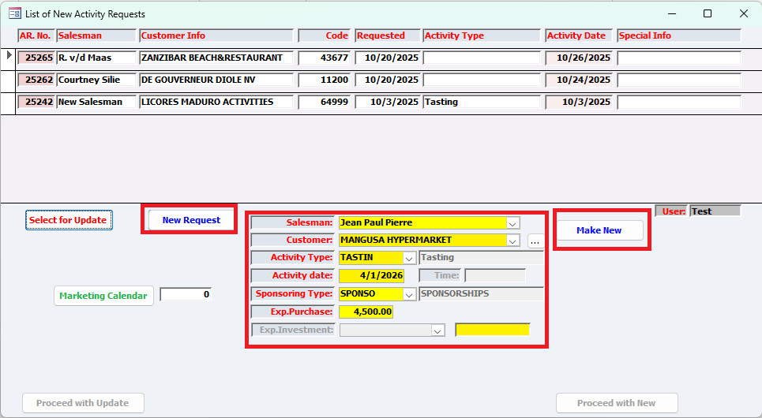
- Press New Activity
- Enter the required fields,
- Press “Make New”.

Plan a budgeted activity in a Marketing Calendar:
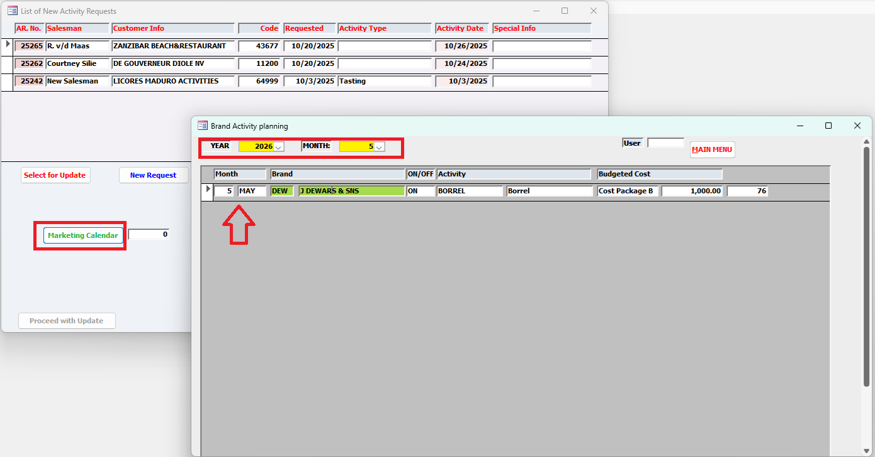

This option can only be done by an authorized user.

- Press the Marketing Calendar button,
A screen will be displayed with the brand activity planning.
Filter on Year and month to display the planned activity of that month.
Select the desired activity by double clicking the green field.
The selected information will be displayed in the next screen.

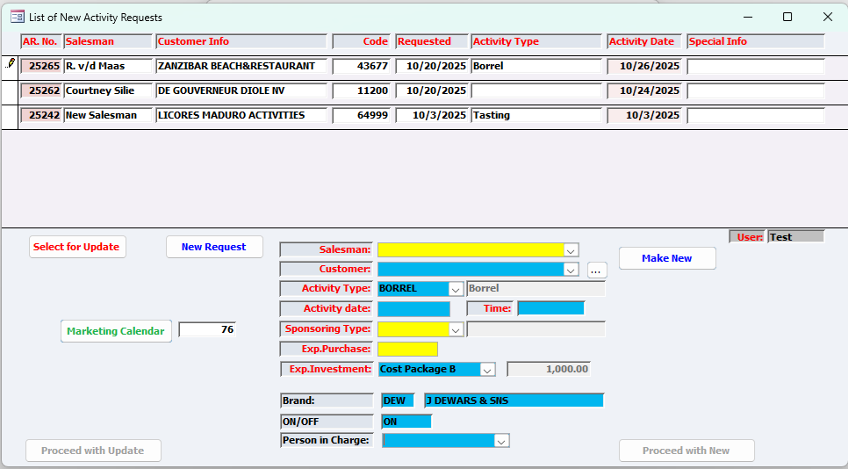
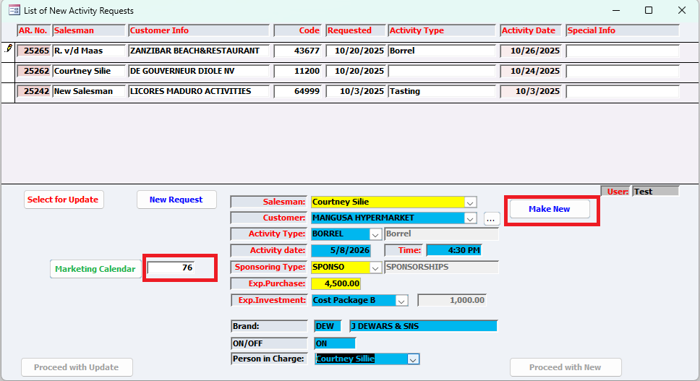

- Enter the missing information, especially the Activity Date to create the activity in the marketing calendar.
- Press “Make new”
A calculation will take place of the activity request created for the customer.
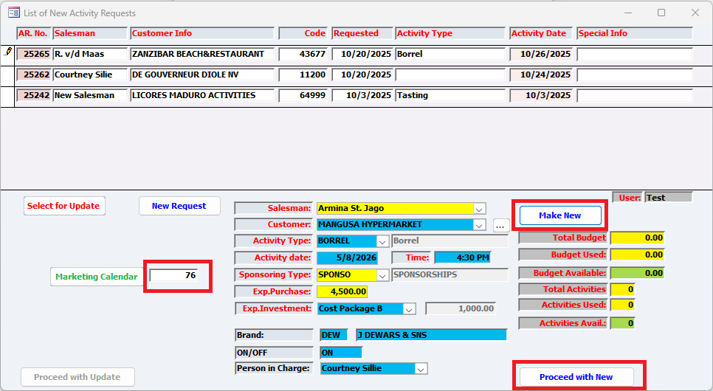

- Press Proceed with New.
The following screen will be displayed to finalize creating the activity request.

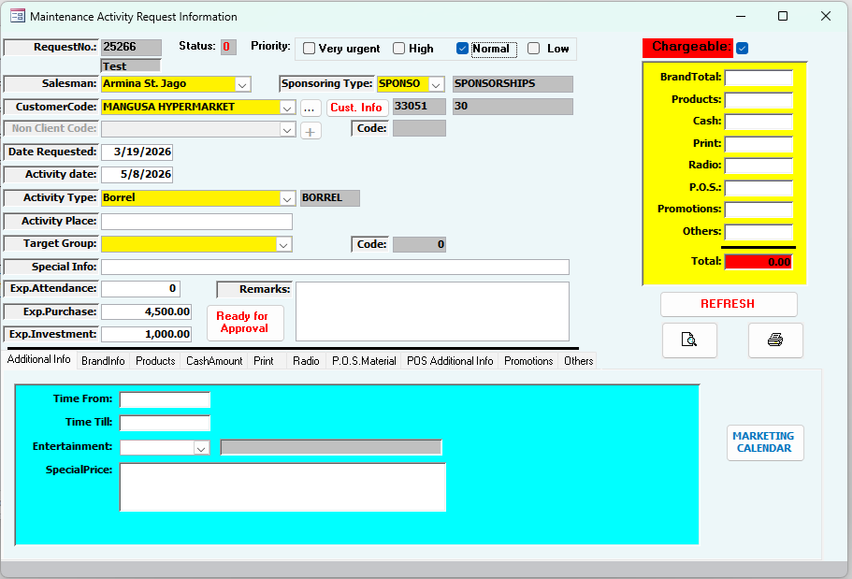

Pressing the “Marketing Calendar button” the Marketing calendar will be displayed with the created activity.
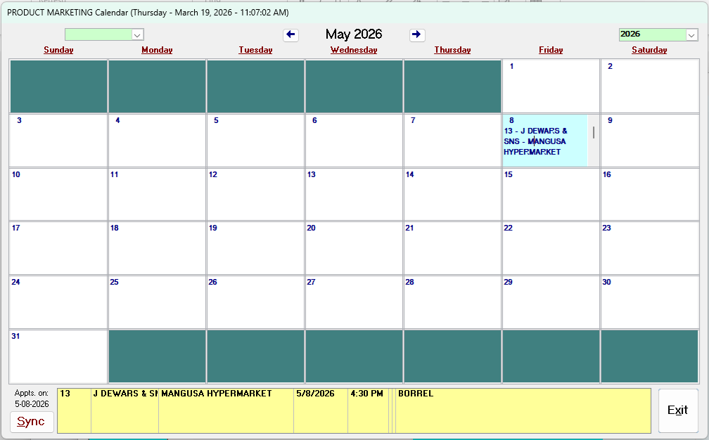

Following are the user Interface screens to register the activity information.

Additional Info:
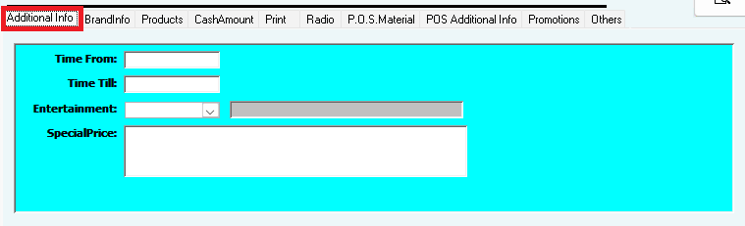

Brand Info:
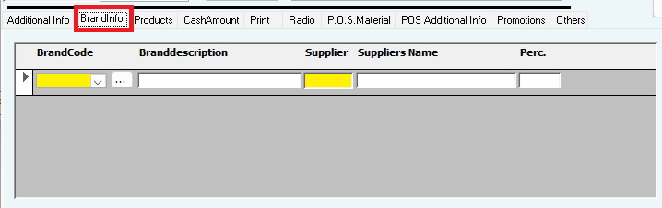
A percentage must be supplied, totals 100%, of the participating brands in this activity.

Products:
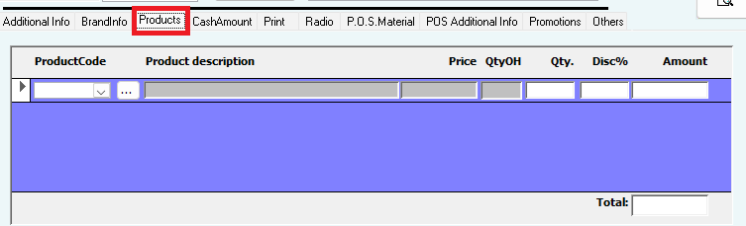
Screen for selection of the products.

Cash Amount:
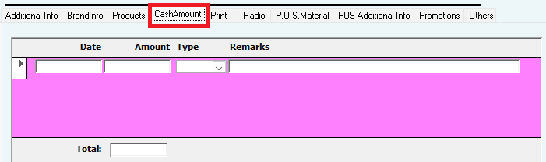

Print:
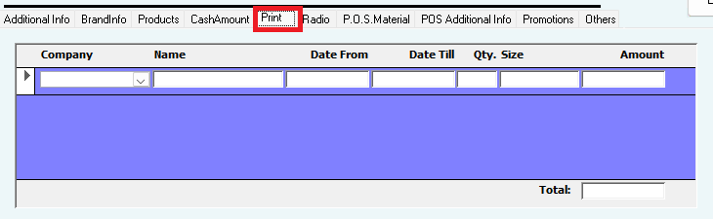
Activity in newspaper with the dates, qty, size and amount.

Radio:
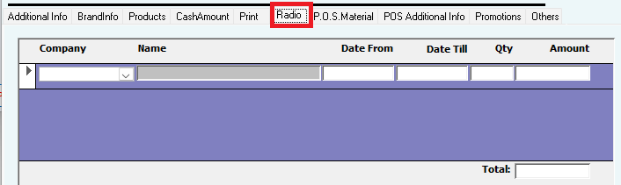
Activity via radio, with dates qty and amount.

POS Materials:
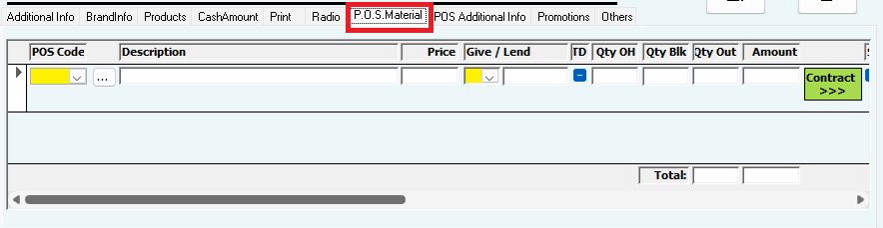
Screen to select the POIS Material that has been registered in the POS Module. Also top be specified is the “give away” or the “Lend Out”.

POS Additional Info:
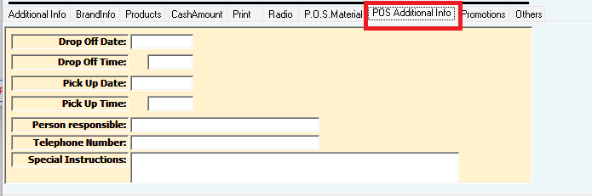

Promotions:
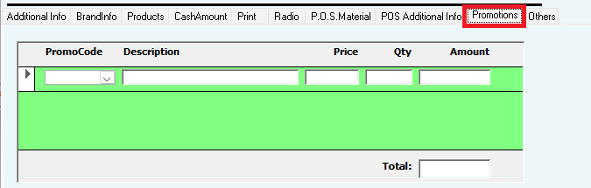

Others:
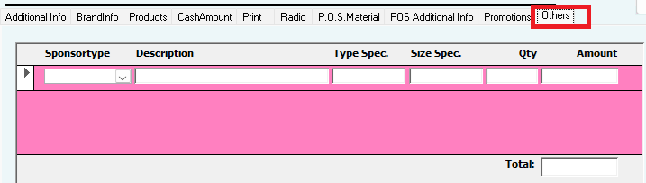

After registering, the activity request will be placed on the “To be approved by Manager” list for approval.

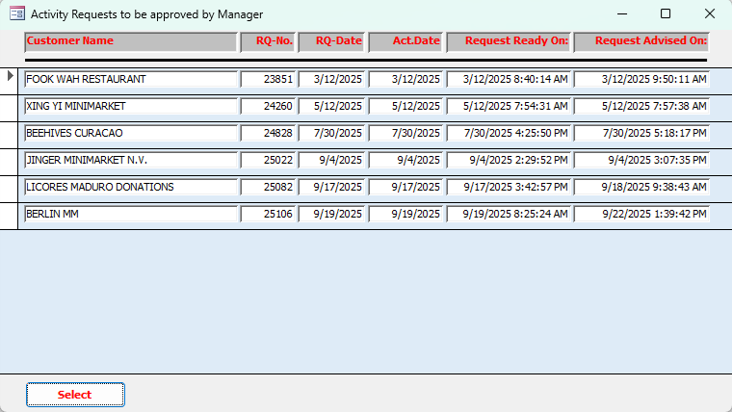

Approved activity Request to be taken into process.
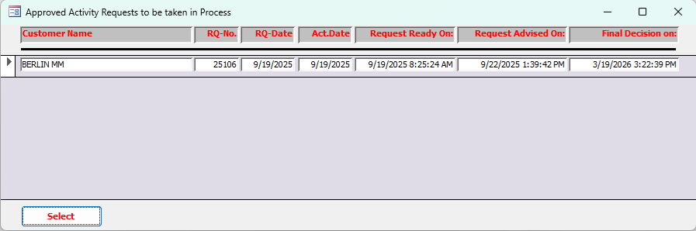

Taking the request into process:
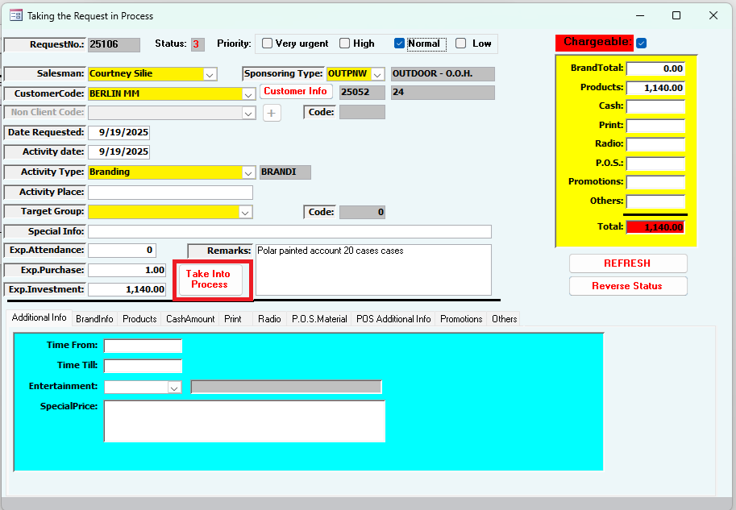

Available budget per brand:
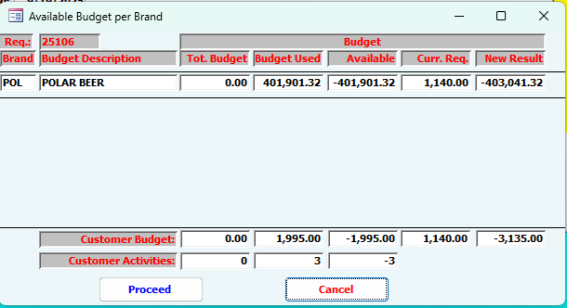

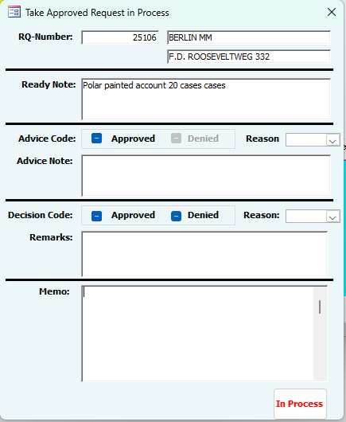

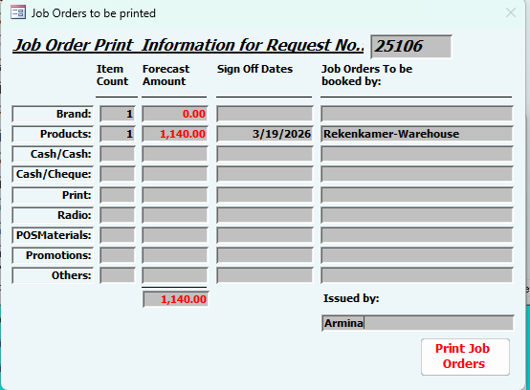

POS MATERIALS:
POS Materials Module Overview
POS (Point of Sale) Materials are promotional products designed to attract the attention of potential buyers at or near the point of purchase. These materials are commonly used in advertising campaigns, exhibitions, and product presentations. When effectively displayed, POS materials enhance brand visibility, influence purchasing decisions, and support overall marketing efforts.

Objective of the Module
The POS Materials Module is designed to:
- Register and maintain a comprehensive record of all existing POS materials
- Track and manage inventory levels
- Administer and monitor all activities related to POS materials, including distribution and usage
- Support marketing initiatives by ensuring the availability and proper utilization of POS assets
This module is integrated within the Activity Request Application, enabling streamlined coordination between marketing activities and POS material management.

User Interface Requirements
User interfaces must be developed to maintain all sub-tables associated with POS Materials. These interfaces should allow users to efficiently create, update, and manage related data.

POS Material Product Specification Interface
A key component of this module is the POS Material Product Specification interface, which requires special attention.
This interface is used to define and manage the specific characteristics of each POS Material. Each material can have a maximum of five (5) specifications, such as:
- Size
- Color
- Material type
- Dimensions
- Finish or format
- Etc.

The interface should ensure:
- Easy input and editing of specifications
- Clear visibility of all defined attributes per POS material
- Validation to enforce the maximum limit of five specifications

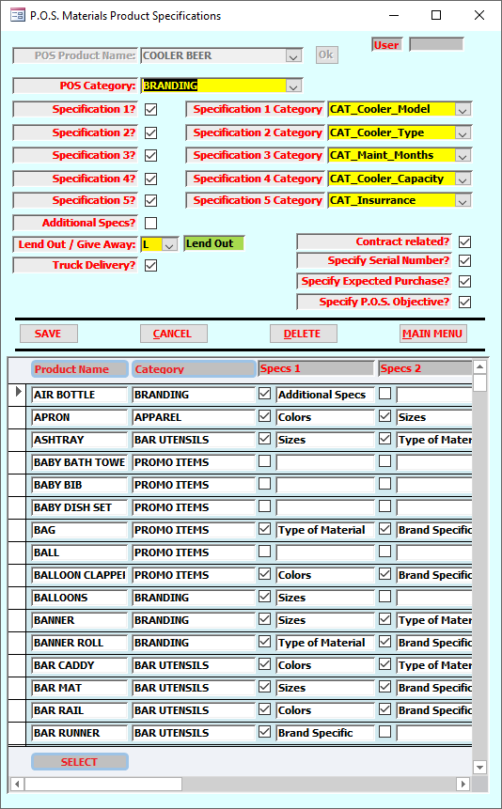

POS Product Name:
This is a unique name, commonly known at Licores Maduro, to identify the POS Material.

POS Category:
Selection from the 5 available category from the POS Category selection table.

Specifications:
To link a specification, first the specification field (1 to 5) has to be checked and subsequently the Specification Category has to be selected from the available list. A maximum of 5 specifications can be linked to a product name.

Additional Specification:
Besides the 5 above mentioned specifications, an additional “additional specification” can be linked to the corresponding product name.

Lend Out / Give Away:
Field to specify whether a POS Material is a “Lend Out” or a “Give Away” Product. “Lend Out” products must be returned to Licores.

Truck Delivery:
Field to specify whether the POS Material must be delivered by truck.

Contract Related?
Field to indicate whether the POS Material is associated with an agreement for which a contract has to be signed between the lender (Licores) and the borrower.

Specify Serial Number?
Field to indicate whether the POS Serial number must be registered when creating the contract.

Specify Expected Purchase?
Field to indicate whether the expected purchase must be specified on the contract.

Specify POS Objective?
Field to indicate whether an objective should be specified for the contract.

Save:
The selection material specification will be saved after the “Save” command key has been pressed.

POS Materials Registration:
This module is to register a POS Material with all its specifications including a picture:
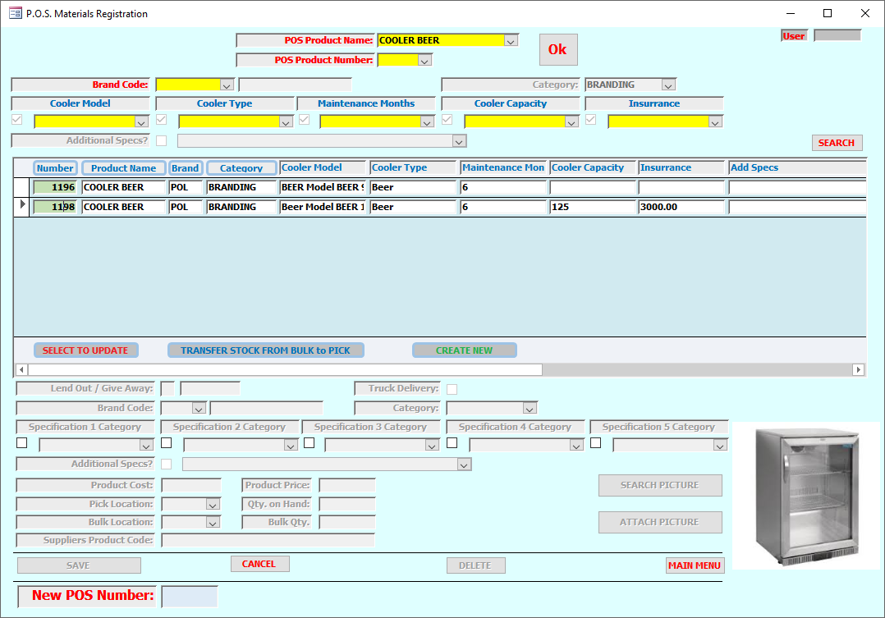

Update information of a selected POS Material:
The information of a POS Material can be updated by selecting the “SELECT TO UPDATE” button.
The fields that can be updated will be colored yellow.

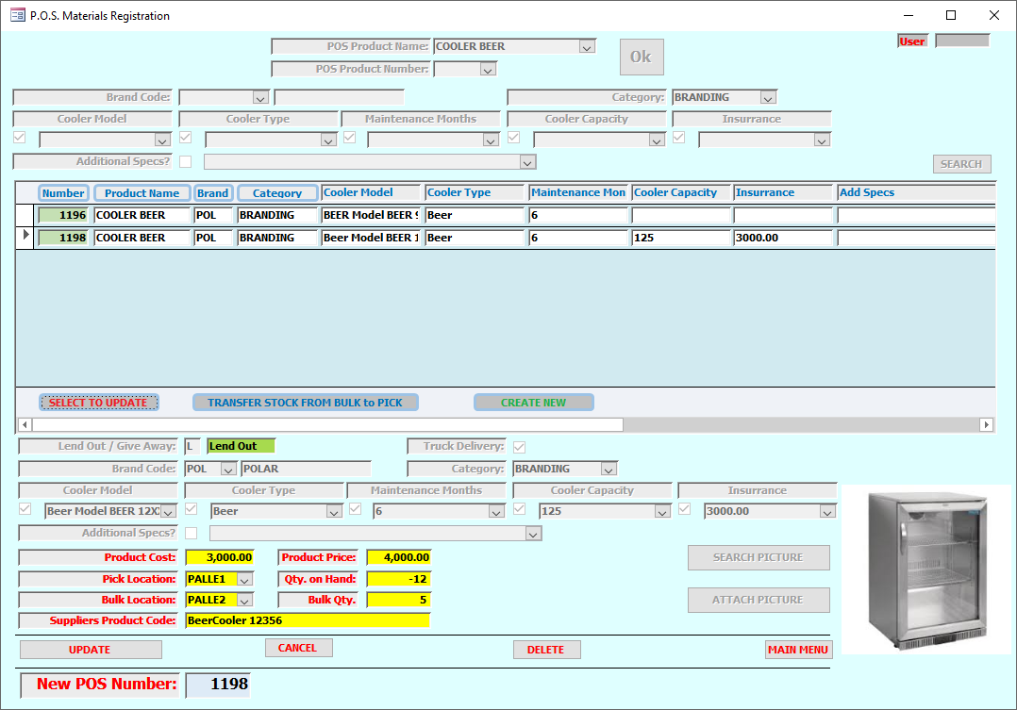

Transfer stock from Bulk location to Pick location of the selected POS Materials:
The stock of the selected POS Material can be transferred from the Bulk location to the Pick location by pressing the “TRANSFER STOCK FROM BULK to PICK” command button.
After selecting this button, a yellow colored field will be displayed to enter the quantity to be transferred.

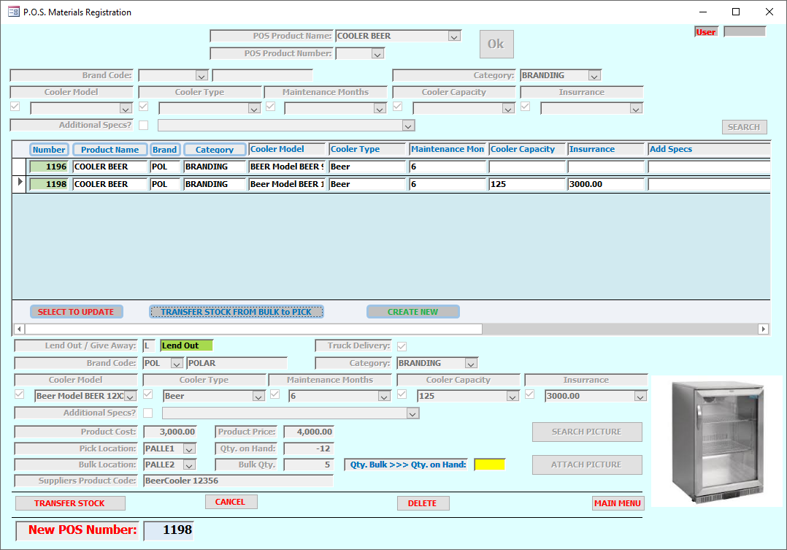

Create a new POS Material:
The command button “CREATE NEW” can be pressed to create a new POS Material after the user has verified that the specific POS Material is not present in the database.
For this purpose, all fields to be entered will be colored “yellow’.
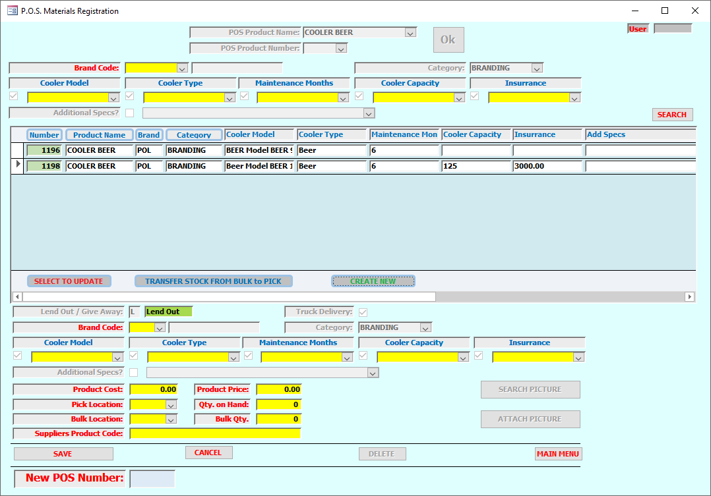
Fields to be entered to register a new POS Material are:
- Brand Code, can be selected from a drop down list,
- Specifications, all relevant specifications that has to be entered are colored yellow and can be selected from the available options from a drop down list. The field headers specify what type of specification can be selected.
- Product Cost,
- Product Price,
- Pick Location, can be selected from a drop down list,
- Qty. on Hand,
- Bulk Location, can be selected from a drop down list,
- Suppliers Product Code, useful when ordering the product,
- Lend Out / Give Away, one of the two options “L” or “G” can be selected.
The new POS material will be created after the “SAVE” button has been pressed. A new POS product number will be created and displayed on the screen.
The “SEARCH PICTURE” command button will be enabled, in order to search the corresponding picture to be attached to the new entered POS Material. On pressing the “ATTACH PICTURE” command key, the picture will be saved.

Pending Returns Lend Out:
This module is to keep track of all POS Materials that have been lend out and still pending to be picked up. After selecting this option, a list will be displayed of all Activity Request still waiting for pick up.
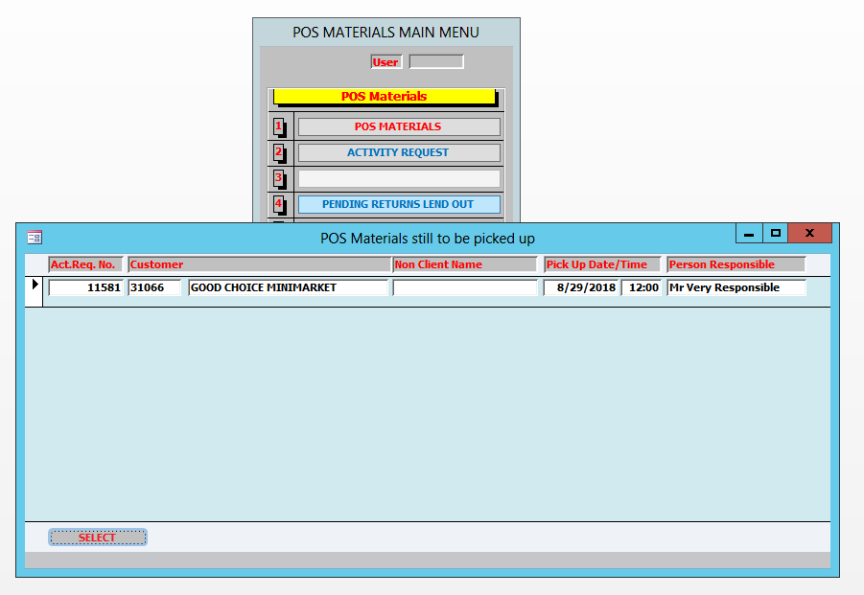

After selecting the concerning Activity Request, a list will be displayed with all lend out POS Materials pertaining to that request together with other additional information registered during creation of the Activity Request.

The following steps must be carried out in order to receive the lend out POS Material.
- Select the concerning POS Material by pressing the “STATUS>>>>” command button; A follow-up screen will be displayed,
- Select the “Date In” from e select calendar,
- Key in the Returned Quantity and select the return Status; The system will display automatically whether the entered quantity will be returned to stock, depending of the selected return status,
- Then press the “Proceed” Button; The total returns must match the Quantity out in order to proceed,
- The system will return to the previous screen to repeat these actions for the next POS Material or to press “READY and Update Stock” to update the stock of the POS Material accordingly.

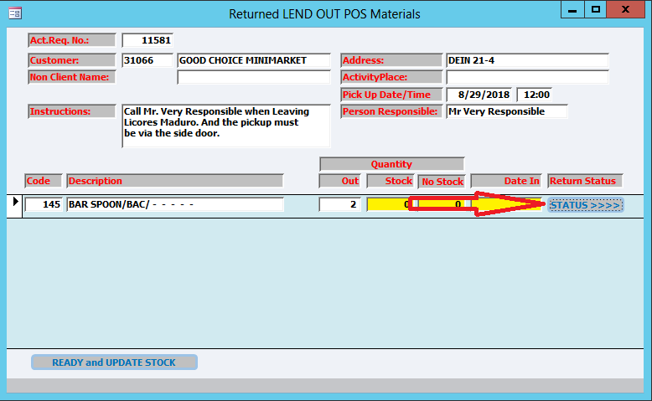
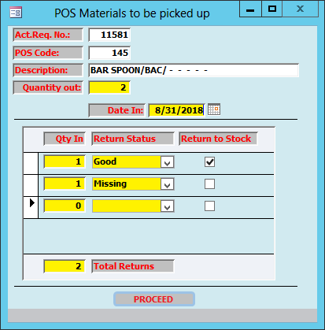

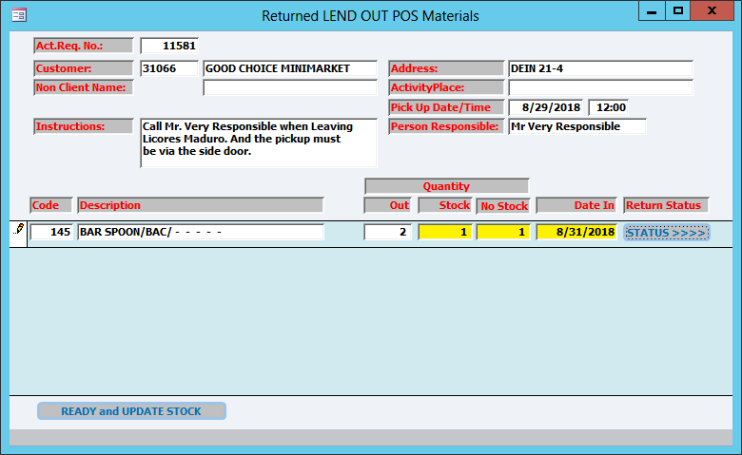

Activity Request Deliverables:

